Heads of EMSA and Frontex meet to discuss cooperation on European coast guard functions.

[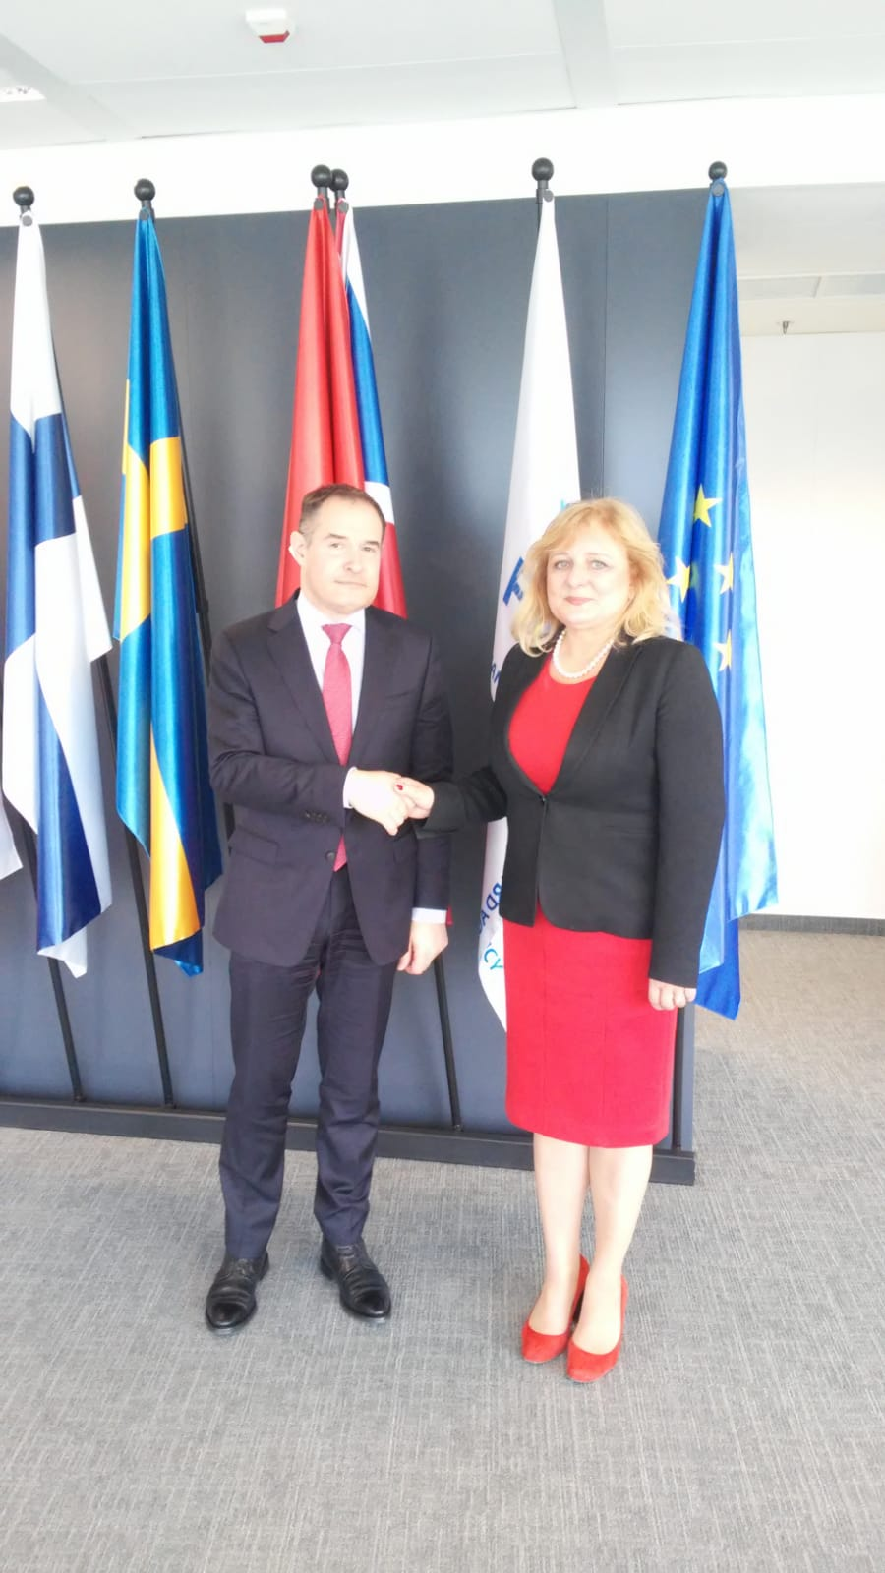](http://www.emsa.europa.eu/images/stories/comm/20190403_press_release.jpg)Today, EMSA Executive Director Maja Markovčić Kostelac visited the headquarters of Frontex, the European Border and Coast Guard Agency, where she met with its Executive Director Fabrice Leggeri to discuss collaboration on the development of European coast guard functions and other forms of cooperation between the two agencies.

Frontex works closely with EMSA, as well as the European Fisheries Control Agency (EFCA), to support Member States with information sharing, surveillance and communication services, capacity building activities as well as risk analysis and information exchange on threats in the maritime domain.

“The close relationship between EMSA and Frontex, along with EFCA, is the foundation of the European coast guard functions. Together we support the activities of more than 300 civilian and military authorities in the EU Member States responsible for carrying out coast guard functions,” said Frontex Executive Director Fabrice Leggeri.

“We provide national authorities with a clear picture of what is happening at sea, in real time. By working together with Frontex and EFCA, we can offer the highest levels of maritime awareness in time-critical scenarios where quick action is needed,” explained EMSA Executive Director Ms Markovčić Kostelac.

Frontex, EMSA and EFCA provide assistance to the national authorities in the maritime domain in a wide range of areas such as maritime safety, security, search and rescue, border control, fisheries control, customs control, general law enforcement and environmental protection.

Each European agency supports the European cooperation on coast guard functions with different objectives and responsibilities. Frontex aims at improving the management of the external borders in order to ensure a high level of internal security in the EU and to tackle cross-border crime. EMSA focuses on enhancing maritime safety, security and prevention of and response to pollution caused by ships and oil and gas installations.

**Source EMSA and FRONTEX**